Create full desktops for users to remotely access centralized apps from anywhere and any device, just with an Internet connection.

www.tsplus.net/remote-access

Sell or rent your access to your applications in a SaaS model. Quickly and easily manage client access to your infrastructure.

Extend the life of your legacy Apps by web-enabling them without redeveloping them. Keep your clients happy with your current UI.

Reduce IT cost by not redeveloping your apps or purchasing expensive alternatives. Our permanent licenses last for life.

Secure your remote connections with TLS encryption.  Add TSplus Advanced Security and TSplus 2FA to maximize your remote infrastructure security.

Easily publish your Windows Applications and deliver them seamlessly to the remote devices of your users.

Discover the ideal alternative to Citrix and Microsoft RDS for remote desktop access and Windows application delivery.

sales@tsplus.net

VISIT OUR WEBSITE

CONTACT US

SECURE YOUR INFRASTRCUTURE

WeB-ENABLE LEGACY APPS

Optimize your it budget

Create a saas solution

Application delivery

Remote desktop access

The ideal alternative to Citrix and rds

remote access and web portal

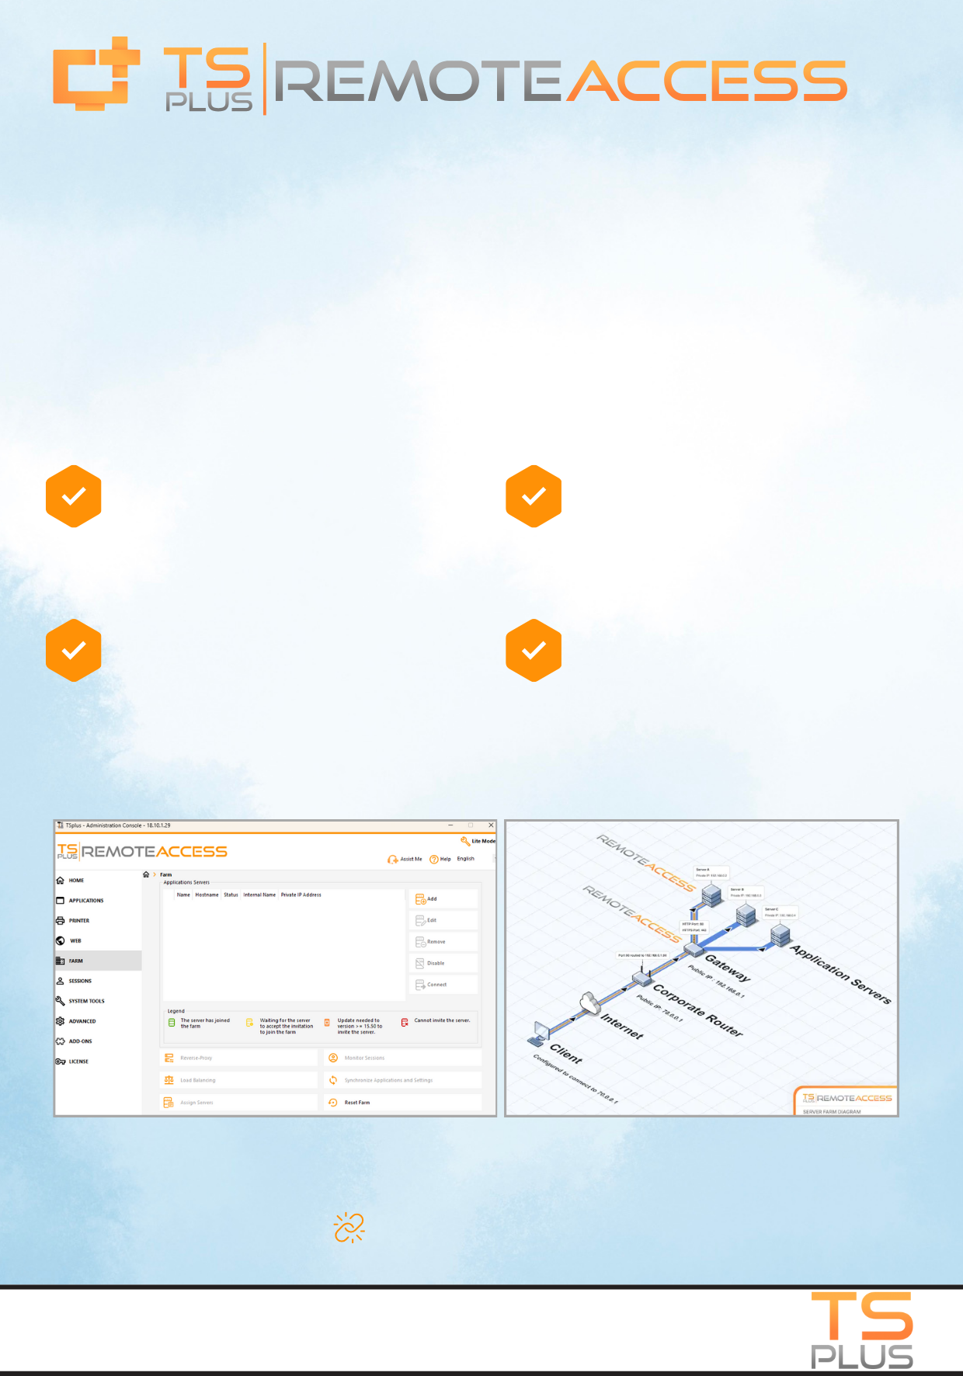

Enterprise Remote Access: central farm manager

sales@tsplus.net

CONTACT US

www.tsplus.net/remote-access

VISIT OUR WEBSITE

Load-balancing: Split the load between multiple servers in your farm. Get failover support during production incidents

Reverse Proxy: Acts as a connection intermediary that prevents Application servers from direct internet access.

Choose Your Architecture: Option 1: All your servers have public IP. Option 2: Only the Gateway Portal can be reached from the Internet

Gateway Web Portal: Using one set of login credentials, users can access multiple servers

With TSplus Farm features, you can easily manage all your Remote Access servers from a single central location, called the Farm Manager. This server becomes your main control hub, turning into a Gateway Server and providing a seamless entry point for your users. You’ll be able to push configurations and manage applications all from one place.

[**LEARN MORE**](http://www.tsplus.net/remote-access/)

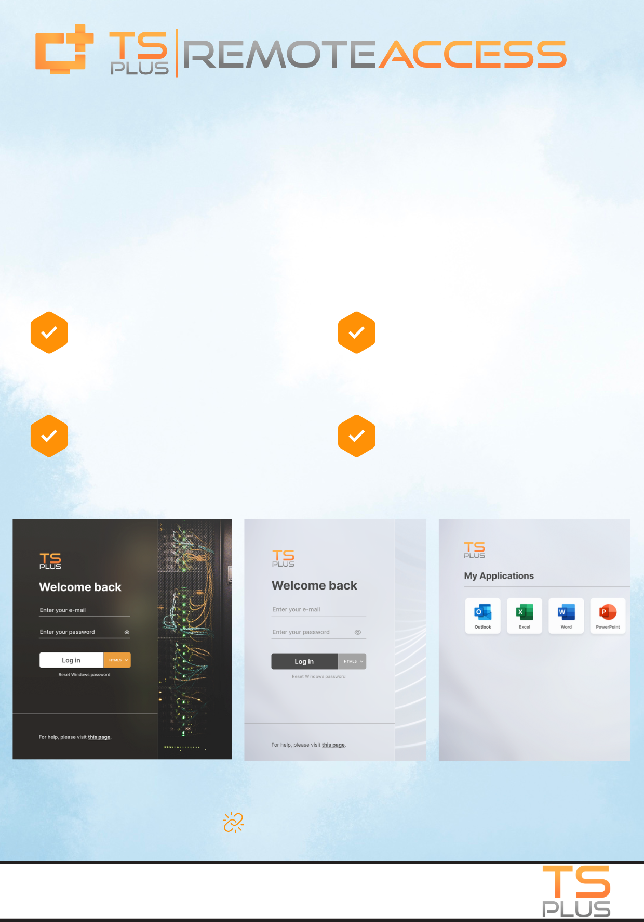

www.tsplus.net/remote-access

AI generated translations: Into all the languages available in Remote Access

Customizable Web Access pages: Add your company name, logo and colors

[**LEARN MORE**](http://www.tsplus.net/remote-access/)

Full access to Unsplash library: Unlimited possibilities for your background picture

Modern & intuitive interface: Enhanced them with real-time, full screen previews

With TSplus Webmaster Toolkit, it is easy to customize Web Access pages with your own branding, graphic chart and pictures of your choice. Remote Access version 17 comes with a brand-new interface and Creative theme designed for a modern and responsive experience offering enhanced esthetics and functionalities.

DISCOVER THE NEW INTUITIVE WEB MASTER TOOLKIT

sales@tsplus.net

VISIT OUR WEBSITE

CONTACT US